**CHAT-DRIVEN E-COMMERCE**

**EXPERIENCE**

### INTERDISCIPLINARY PROJECT

Submitted in partial fulfillment of the requirements for the award of Bachelor of Engineering degree in Computer Science and Engineering

By

### KATTA SYAMKUMAR (Reg. No – 41110609)



**DEPARTMENT OF COMPUTER SCIENCE AND ENGINEERING**

## **SCHOOL OF COMPUTING**

SATHYABAMA

### INSTITUTE OF SCIENCE AND TECHNOLOGY

### (DEEMED TO BE UNIVERSITY)

**CATEGORY - 1 UNIVERSITY BY UGC**

### Accredited “A++” by NAAC I Approved by AICTE JEPPIAAR NAGAR, RAJIV GANDHI SALAI, CHENNAI - 600119

**APRIL - 2024**



### DEPARTMENT OF COMPUTER SCIENCE AND ENGINEERING

**BONAFIDE CERTIFICATE**

This is to certify that this Project Report is the bonafide work of **KATTA SYAMKUMAR (41110609)** who carried out the Project entitled “**CHAT-DRIVEN E-COMMERCE EXPERIENCE**” under my supervision from January 2024 to April 2024.

### Internal Guide

**Ms. LAKSHMI PRIYA S, M.E., (Ph.D).,**

### Head of the Department

**Dr. L. LAKSHMANAN, M.E., Ph.D.,**

### Submitted for Interdisciplinary Viva Voce Examination held on

**Internal Examiner External Examiner**

### DECLARATION

I, **Katta Syamkumar (Reg. No- 41110609),** hereby declare that the Project Report entitled **“CHAT-DRIVEN E-COMMERCE EXPERIENCE”** done by me under the guidance of **Ms. Lakshmi Priya S, M.E., (Ph.D).,** is submitted in partial fulfillment of the requirements for the award of Bachelor of Engineering degree in **Computer Science and Engineering**.

### DATE:

**PLACE: Chennai SIGNATURE OF THE CANDIDATE**

### 

### ACKNOWLEDGEMENT

I am pleased to acknowledge my sincere thanks to **Board of Management** of **Sathyabama Institute of Science and Technology** for their kind encouragement in doing this project and for completing it successfully. I am grateful to them.

I convey my thanks to **Dr. T. Sasikala, M.E., Ph. D.**, **Dean**, School of Computing, and

**Dr. L. Lakshmanan, M.E., Ph.D., Head of the Department** of Computer Science and Engineering for providing me necessary support and details at the right time during the progressive reviews.

I would like to express my sincere and deep sense of gratitude to my Project Guide **Ms.**

**Lakshmi Priya S, M.E., (Ph.D).,** for her valuable guidance, suggestions, and constant encouragement paved way for the successful completion of my project work.

I wish to express my thanks to all Teaching and Non-teaching staff members of the **Department of Computer Science and Engineering** who were helpful in many ways for the completion of the project.

**NPTEL HALL TICKET**



**ABSTRACT**

This paper presents an online marketplace tailored for buying and selling agricultural products, featuring a Java-based chat box and MySQL database. The website aims to simplify the process of agricultural trade by connecting farmers, distributors, and consumers. The Java chat box allows for real-time communication between buyers and sellers, enhancing trust and facilitating smoother transactions. Additionally, the MySQL database efficiently manages product listings, user profiles, and transaction data. This paper outlines the design and implementation of the e-marketplace, emphasizing its potential to improve accessibility and efficiency in agricultural trade. Through user testing and feedback, we evaluate the platform's usability and its role in promoting economic development in rural communities. The Java chat box showcases various features such as emoji reactions and message pinning, enhancing the conversational experience. Moreover, users benefit from clear indicators for new messages and notifications, ensuring they stay updated. The chat box also supports group discussions, facilitating collaborative decision-making. Furthermore, the platform offers comprehensive customer support through the chat box, ensuring prompt assistance. Users can readily access price details of products, enabling informed decisions and transparent transactions. These user-centric elements collectively enhance the platform's appeal and foster a positive trading environment.

# TABEL OF CONTENTS

|  |  |  |
| --- | --- | --- |
| **CHAPTER NO.** | **TITLE** | **PAGE NO.** |
|  | **ABSTRACT** | vi |
|  | **LIST OF FIGURES** | ix |
| **1** | **INTRODUCTION** | 1 |
|  | 1.1 OVERVIEW | 1 |
| **2** | **LITERATURE SURVEY** | 3 |
| **3** | **AIM AND SCOPE OF THE PRESENTATION** | 5 |
|  | 3.1 AIM OF PROJECT | 5 |
|  | 3.2 SCOPE OF PROJECT | 5 |
|  | 3.3 SYSTEM REQUIREMENTS | 6 |
|  | 3.3.1 HARDWARE REQUIREMENTS | 6 |
|  | 3.3.2 SOFTWARE REQUIREMENTS | 6 |
|  | 3.4 SOFTWARE USED | 6 |
|  | 3.4.1 MY SQL DATABASE | 6 |
|  | 3.4.2 HTML | 7 |
|  | 3.4.3 PHP | 7 |
|  | 3.4.4 JAVA SCRIPT | 8 |
|  | 3.4.5 CSS | 8 |
|  | 3.4.6 VS CODE | 8 |
|  | 3.4.7 XAMPP | 9 |
| **4** | **EXPERIMENTAL OR MATERIAL METHODS** | 10 |
|  | 4.1 DESIGN METHODOLOGY | 10 |
|  | 4.2 EXISTING SYSTEM | 10 |
|  | 4.3 PROPOSED SYSTEM | 10 |
|  | 4.3.1 ADVANTAGES | 11 |
|  | 4.3.2 DISADVANTAGES | 11 |
|  | 4.4 MODULES | 12 |
|  | 4.5 SYSTEM ARCHITECTURE | 16 |
|  | 4.6 ACTIVITY DIAGRAM | 17 |
| **5** | **RESULT AND DISCUSSION** | 18 |
|  | 5.1 PHP MY ADMIN | 18 |
|  | 5.2 HOME PAGE | 19 |
|  | 5.3 LOGIN PAGE | 20 |
|  | 5.4 SELLER FORM | 21 |
|  | 5.5 PRODUCTS PAGE | 22 |
|  | 5.6 SQL DATABASE | 23 |
|  | 5.7 CHATBOT | 24 |
|  | 5.8 CHAT ASSIST | 25 |
|  | 5.9 PAYMENT PAGE | 26 |
|  | 5.10 RESULT | 27 |
| **6** | **CONCLUSION AND FUTURE WORK** | 28 |
|  | **REFERENCES** | 29 |
|  | **APPENDIX** | 30 |

# LIST OF FIGURES

|  |  |  |
| --- | --- | --- |
| **FIGURE NO.** | **FIGURE NAME** | **PAGE NO.** |
| 5.1 | PHP My Admin | 18 |
| 5.2 | Home Page | 19 |
| 5.3 | Login Page | 20 |
| 5.4 | Seller Form | 21 |
| 5.5 | Products Page | 22 |
| 5.6 | SQL Database | 23 |
| 5.7 | Chatbot | 24 |
| 5.8 | Chat Assist | 25 |
| 5.9 | Payment | 26 |

**CHAPTER 1**

# INTRODUCTION

* 1. **OVERVIEW**

E-commerce is the purchasing of goods and services over a network. It is powered by the internet, where customers can purchase from an online store.e- commerce is further classified into 4 major types, which includes :(i)Business-to- Business(B2B), (ii)Business-to-Consumer, (iii)Consumer-to-Consumer(C2C), (iv)Consumer-to-Business(C2B)

The following happens when your order is placed. The browser will communicate with the online store, soon after the order is placed. Post order validation, the order manager will notify the store’s web server, which will then display a message notifying that their order has been successfully processed. After this, the order details will be sent to the warehouse for dispatch.

Agriculture is the largest dependent sector in India. Farmers are struggling for their daily needs. When they go and sell their products in the market, they don’t get expected profit as people tend to bargain. If the same is sold online, people purchase without any second thoughts. For the ease of farmers, we have created a hands-on application with a simple user-friendly interface. chatbot called Assist helps customers on an online shopping website. It answers questions, finds products, and guides shoppers through their purchases. It's like having a friendly helper available 24/7 to make shopping easier for everyone

The crops are cultivated according to the season, and once it is harvested, it can be posted for sale online. Normally, farmers will contact the wholesale vendors to sell the crops. The vendor may quote a lower price to gain profits.

Innovation is the main impetus in each area. Subsequently, we utilize this innovation to drive the farmers into a productive way. We have developed this application in such a way that, there will be no vendors, and it will be a direct interaction between the farmers and the customers. Our main aim is to make their business more efficient and profitable with the new technology.

Our chatbot, Assist, plays a pivotal role in facilitating seamless communication between farmers and shoppers. With its intuitive interface and natural language processing capabilities, Assist assists customers in finding the right products, answering queries about farming practices, and providing valuable insights into agricultural trends. By harnessing the power of technology, we aim to revolutionize the way agricultural products are bought and sold, ensuring a fair and prosperous future for farmers while meeting the evolving needs of consumers in the digital age. Through our platform, farmers gain direct access to a vast consumer base without the need for intermediaries, empowering them to set fair prices for their produce and maximize their profits. Additionally, Assist serves as a knowledge repository, offering guidance on sustainable farming techniques, market trends, and crop management practices. By fostering direct engagement between farmers and consumers, we not only streamline the agricultural supply chain but also foster a deeper connection between producers and the end-users of their products. Our commitment to leveraging technology for social good drives us to continuously enhance our platform, ensuring that it remains a valuable tool for farmers and shoppers alike in navigating the ever-changing landscape of e-commerce in agriculture.

# CHAPTER 2

**LITERATURE SURVEY**

1. **Multi Vendor E-commerce Website for Farmers by Gomathy C.K, Jaswanth Reddy Vulchi, Venkatesh Pathipati in 2021**

As we all know that e-commerce is an emerging field in this digital world, all are familiar and known with this technology. There are no boundaries in this field, urban to rural all are frequently using online buying and selling operations in various aspects of their livelihood. Food is one of the major needs of human beings, which is fulfilled by the farmers. Right now, the farmers are failing to get a proper price for their products. So, now we are bringing new and unique thought into action that is an ecommerce website for farmers. We are trying to do a small help for farmers through this website. E- commerce is opening to have a crucial impact in the farming sector. This is an e- commerce website for farmers to ease their work in agriculture by providing a simple online platform using the latest technologies. Apart from this, we are also providing information about the new techniques and latest technologies in the agricultural sector. This will supervise the farmer’s entrance to the new farming techniques and also helps in comparing the present market rate of different products. This will help the farmers for the utilization of current technology to find out the profitable ways for income. And also it reduces the extra costs like transport and labour to the farmers. The farmer can save time for the sake of searching for their desired seeds in the market as we are providing a single easy platform. A User-friendly interface helps the farmer to make the desired operations easily.

1. **E-commerce site for agricultural products by Megha Nayak, Pinky ankhede, Neha Khapekar, Komal Dhote in 2019**

E-commerce is clearly beginning to have a major impact in the agricultural sector. The way people go about purchasing agricultural products is of great concern. Most of the time customers have to travel far distances to get agricultural products and getting the right quality is not ensured. Our project aims to help farmers as well as customers for buying and selling agricultural products across the country using a computerized approach. The website will guide the farmers to access new farming techniques, compare current market rate of different products, the total sale and the earned profit for the sold products. The website builds a platform for farmers to ensure greater profitability through end user communication. The website will act as a unique and secure way to perform agro-marketing. E-farming will serve as a way for the farmers to sell their products across the country just with some basic knowledge about how to use the website. This project allows viewing various products available enables users to purchase desire products instantly by online payment.

# CHAPTER 3

## **AIM AND SCOPE OF THE PRESENTATION**

# 3.1 AIM OF PROJECT

The purpose of e-commerce websites is to facilitate online trade easily for both sellers and buyers. This can be domestic trade by means of B2C / B2B e-commerce website or international trade by means of B2C / B2B e-commerce websites.

E-commerce websites usually integrate payment gateway into their website to accept online payments for their products sale. They also have logistic partners to deliver the products to their customers house on time. Usually e-commerce websites offers lots of promotional schemes for both sellers and buyers to keep them at their e-commerce platform and grow accordingly.

# 3.2 SCOPE OF PROJECT

eCommerce is still not at its peak and the scope of the eCommerce business in India is still big. Thanks to the advancements of social media and mobile technology, online shopping has become a new way of life. As you know people are now going online to shop for clothes, appliances, furniture, and a lot more.

Another significant contributor to the future scope of eCommerce in India is the e- tailing industry which largely deals in providing jewelry, apparel, and kitchen appliances online. Websites like Flipkart, Myntra, Amazon, Snapdeal, Jabong, etc. are all examples of the enormous success of eCommerce in India. With the increasing penetration of smartphones and internet connectivity, even rural areas are becoming active participants in the e-commerce ecosystem, expanding the market potential further. As consumers continue to embrace the convenience and variety offered by online shopping platforms.

**3.3 SYSTEM REQUIREMENTS**

**3.3.1 Hardware Requirements**

The selection of hardware is very important in the existence and proper working of any software. When selecting the hardware, the size and requirements are also important to run the software.

The minimum hardware requirements are as follows

• **PROCESSOR :** Intel CORE i3

• **RAM :** 4 GB

• **DISK SPACE :** Minimum 256 GB

**3.3.2. Software Requirements**

•  **OPERATING SYSTEM :** Windows 7 Or Mac OS

•  **FRONT END :** HTML , CSS ,JavaScript

•  **BACK END :** PHP ,MY SQL(XAMPP)

• **Code Editor :** Visual Studio Code

**3.4 SOFTWARE USED**

**3.4.1 MySQL Database**

MySQL is free and open-source software under the terms of the GNU General Public License, and is also available under a variety of proprietary licenses. MySQL was owned and sponsored by the Swedish company MySQL AB, which was bought by Sun Microsystems (now Oracle Corporation). In 2010, when Oracle acquired Sun, Widenius forked the open-source MySQL project to create MariaDB.

MySQL has stand-alone clients that allow users to interact directly with a MySQL database using SQL, but more often, MySQL is used with other programs to implement applications that need relational database capability. MySQL is a component of the LAMP web application software stack (and others), which is an acronym for Linux, Apache, MySQL, Perl/PHP/Python. MySQL is used by many database-driven web applications, including Drupal, Joomla, phpBB, and WordPress. MySQL is also used by many popular websites, including Facebook, Flickr, MediaWiki, Twitter, and YouTube.

**3.4.2 HTML**

HTML, or HyperText Markup Language, is the fundamental language of the internet, providing the structure for web pages. It uses tags to define various elements such as headings, paragraphs, links, and images, allowing creators to organize content in a readable and accessible manner. Each HTML document comprises a declaration, specifying the document type, followed by a hierarchical structure consisting of the <html>, <head>, and <body> elements. Within these elements, content is formatted and presented to users by web browsers. Learning HTML empowers individuals to craft their own web pages and share information globally.

**3.4.3 PHP**

PHP is a versatile scripting language commonly used for web development, offering a straightforward way to create dynamic and interactive web pages. With PHP, developers can embed code directly into HTML, allowing them to generate content dynamically based on user input or database information. PHP is known for its flexibility, scalability, and extensive support across various platforms, making it a popular choice for building websites, web applications, and content management systems. Its simplicity and broad community support make PHP accessible to beginners while offering powerful features for experienced developers to create robust and feature-rich web solutions.

**3.4.4 JAVA SCRIPT**

JavaScript is a programming language primarily used to make websites interactive and dynamic. It runs directly in a web browser, allowing developers to manipulate webpage elements, respond to user actions, and update content without needing to reload the page. JavaScript is versatile, supporting a wide range of applications from simple animations to complex web applications.

It is commonly used alongside HTML and CSS to enhance the functionality and user experience of websites. JavaScript's simplicity and widespread adoption make it an essential skill for web developers looking to create engaging and responsive web experiences.

**3.4.5 CSS**

CSS, short for Cascading Style Sheets, is a styling language used to control the presentation and layout of HTML documents. It defines how elements are displayed on a web page, including their colors, fonts, sizes, spacing, and positioning. CSS allows developers to separate the structure of a webpage (defined by HTML) from its visual design, making it easier to maintain and update. By applying CSS rules to HTML elements, designers can create visually appealing and responsive web pages that adapt to different screen sizes and devices. CSS is essential for creating attractive and consistent web designs, enhancing user experience, and ensuring accessibility across various platforms and browser.

**3.4.6 VS CODE**

Visual Studio Code (VS Code) is a software program used by developers to write, edit, and debug code for various programming languages. It provides a user-friendly interface with features like syntax highlighting, code completion, and integrated terminal for running commands. VS Code supports extensions, which are additional tools and features that can be added to customize and enhance the coding experience. Developers use VS Code to create web applications, software programs, and other digital projects efficiently. An online server is a remote computer or system that hosts websites, applications, or databases accessible over the internet. It stores website files, processes requests from users, and delivers web content to their browsers. Online servers provide the infrastructure and resources needed to run websites and web applications smoothly. Developers can deploy their projects to online servers to make them accessible to users worldwide. Online servers offer scalability, reliability, and security features, making them essential for hosting websites and delivering online services effectively.

**3.4.7 XAMPP**

XAMPP is a software package that makes it easy to set up a web development environment on your computer. It includes several components needed to run web applications locally, such as Apache, MySQL, PHP, and Perl.

Apache is a web server software that serves your web pages to visitors' browsers when they request them. MySQL is a database management system used to store and manage data for your web applications. PHP is a programming language that is commonly used to create dynamic web pages, allowing you to interact with databases and create interactive features on your website. Perl is another programming language that can be used for various web development tasks, With XAMPP, you can install all these components on your computer with just a few clicks, allowing you to develop and test your web applications locally before deploying them to a live server. This makes it easier to troubleshoot issues and make changes to your code without affecting your live website. XAMPP is a popular choice for developers who want to create and test web applications on their own computers before making them available to the public.

**CHAPTER 4**

**EXPERIMENTAL OR MATERIAL METHODS**

**4.1 DESIGN METHODOLOGY**

The application is developed using HTML, CSS, JAVA SCRIPT and SQL database. This is a simple e- commerce application developed for farmers to sell their products easier, and enabling buyers to purchase their products.

We have not used any specific algorithm to develop this project. It all works in simple Java coding and connection to database. Registration of each category of user is saved in the database. As we add products into the store, it is stored in the database for the buyers to know the stock availability before purchasing the same. If the same is not available, they can contact the store and order.

# 4.2 EXISTING SYSTEM

In the existing e-commerce portal to sell crops/fruits/vegetables, there is an intermediate vendor or multi-vendors through which the products are sold to us. Here, the vendor bargain with the farmers and get it at a very low cost and sell it to the customers at a high price, thereby earning profits, which in turn affects the farmers as they don’t even get the amount invested in the crops.

# 4.3 PROPOSED SYSTEM

In this application, we have removed the need of intermediate vendors. That is, the farmers can directly sell their end products online to the customers. Since this application has a very simple UI, they won’t face much difficulties navigating through. In this way, it is ensured that farmers get the maximum profit. Moreover, by eliminating intermediaries, we empower farmers to establish direct connections with consumers, fostering transparency and fair pricing in the agricultural supply chain.

**4.3.1 Advantages**

1. Increased Market Reach: The eCommerce platform allows farmers to reach a wider audience beyond their local markets, enabling them to sell their produce to customers in different regions or even countries.
2. Direct Interaction: Cutting out middlemen or wholesalers means farmers can establish direct relationships with consumers, leading to better communication, understanding of customer preferences, and potentially higher profits.
3. Reduced Overhead Costs: By selling online, farmers can save on overhead costs associated with traditional brick-and-mortar stores, such as rent, utilities, and staffing.

**4.3.2 Disadvantages**

1. Technical Challenges: Farmers may face challenges in adapting to technology and managing online platforms, such as website maintenance, inventory management, and order fulfillment.
2. Digital Divide: Not all farmers may have access to the necessary technology or internet connectivity required to participate in eCommerce, leading to disparities in market access and opportunities.
3. Competition: As eCommerce platforms become increasingly popular, farmers may face stiff competition from other sellers, both locally and globally, making it harder to stand out and attract customers.

**4.4 MODULES**

The modules involved are

* Login
* Product Management
* Order Processing
* Customer Interaction
* Product Recommendations
* Order Assistance
* Customer Engagement
* Learning and Improvement
* **MODULES DESCRIPTION**

**Login:**

This module allows users to authenticate themselves by entering their credentials (username and password) to access the system. It provides a secure gateway for users to log in and utilize the system's functionalities.

**Product Management:**

* Allows farmers to add, edit, and manage their agricultural products, including descriptions, prices, and images.
* Provides features for categorizing products by type (e.g., fertilizers, seeds, tools) and seasonality.
* Includes inventory management capabilities to track product availability and update stock levels.

**Order processing:**

* Facilitates the processing of orders placed by customers, including order validation, payment processing, and order fulfillment.
* Integrates with payment gateways to securely process online payments and generate order invoices.
* Provides notifications to farmers and customers regarding order status updates, such as order confirmation, shipment tracking, and delivery.

**Customer Interaction**

* Incorporates a chatbot module to assist users with product inquiries, order assistance, and general queries.
* Enables farmers to communicate directly with customers, respond to feedback, and address customer concerns in real-time.
* Integrates feedback mechanisms to collect customer reviews, ratings, and suggestions for improving products and services.

**Product Recommendations**

* Utilizes chatbot functionality to analyze user preferences, browsing history, and previous interactions to suggest relevant products and promotions.
* Provides personalized recommendations tailored to individual user preferences, increasing the likelihood of successful conversions.
* Offers options for users to explore product recommendations based on specific criteria, such as product type, price range, or seasonal availability.

**Order Assistance**

* Enables users to inquire about order status, track shipments, and request assistance with order modifications, cancellations, or returns through the chatbot.
* Provides real-time updates on order progress, including confirmation messages, shipping notifications, and delivery confirmations.
* Assists users in resolving order-related issues, such as payment errors, shipping delays, or product discrepancies, through interactive chat sessions.

**Customer Engagement**

* Engages users proactively through automated messages, reminders, and notifications to encourage repeat purchases and increase customer loyalty.
* Facilitates personalized interactions with users, such as greeting returning customers by name, recommending products based on past purchases, and offering exclusive discounts or promotions.
* Collects feedback and insights from users to improve chatbot performance, enhance user experience.

**Learning and Improvement**

* Implements mechanisms for continuous learning and improvement, allowing the chatbot to adapt and evolve based on user feedback, conversation history, and performance metrics.
* Utilizes analytics and reporting features to track chatbot usage, user engagement, conversion rates, and customer satisfaction scores.
* Incorporates feedback loops and iterative development processes to iterate on chatbot functionality, refine conversation flows, and address user needs more effectively over time.

These modules work together to make buying and selling agricultural products online easier and more efficient. Farmers can manage their products, process orders, and communicate with customers seamlessly. With the help of chatbots, customers can get personalized recommendations, track their orders, and receive assistance whenever they need it. This approach not only benefits farmers by expanding their market reach and increasing sales but also enhances the shopping experience for customers. By continuously learning and improving, the platform adapts to meet the changing needs of both farmers and shoppers, ensuring a smooth and successful eCommerce journey for everyone involved. Furthermore, the integration of these modules creates a cohesive ecosystem where farmers can easily monitor inventory, streamline order fulfillment, and engage with buyers in real-time. Through the intuitive interface of chatbots, customers receive tailored suggestions, track shipments effortlessly, and enjoy prompt support, enriching their shopping journey. This holistic approach not only drives growth and profitability for farmers through expanded market access and increased customer engagement but also elevates the overall satisfaction of shoppers. Continual refinement and innovation enable the platform to stay ahead of market dynamics, catering to the evolving preferences of both sellers and buyers, thereby ensuring sustained success and mutual benefit in the realm of e-commerce for agricultural products. Moreover, the platform's data analytics capabilities empower farmers with valuable insights into consumer preferences and market trends, enabling informed decision-making and targeted product offerings. Seamless integration with payment gateways ensures secure transactions, fostering trust and reliability among both parties.

**4.5 SYSTEM ARCHITECTURE**

System analysis is the process of defining the architecture, components, and data of a system to satisfy specified requirements. Design is a method of studying a system by examining its component parts and their interactions. Before implementation began the system was analyzed and designed.

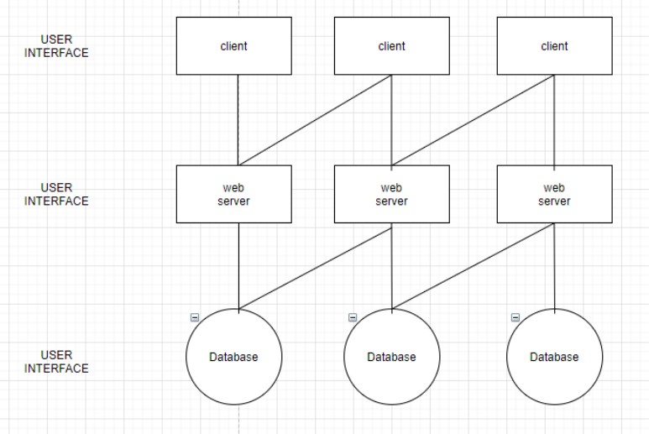

*Fig – 4.4 SYSTEM ARCHITECTURE*

This thorough analysis and design phase lays the foundation for a robust and efficient system implementation. By understanding the intricacies of the system's architecture and interactions, potential pitfalls can be identified and addressed proactively. Moreover, this systematic approach ensures that the final solution aligns closely with the intended objectives, enhancing its effectiveness and reliability. by dissecting the system's components and their relationships, potential

**4.6 ACTIVITY DIAGRAM**

UML models are basically three types of diagrams, namely, structure diagrams, interaction diagrams, and behavior diagrams. An activity diagram is a behavioral diagram i.e., it depicts the behavior of a system. An activity diagram portrays the control flow from a start point to a finish point showing the various decision paths that exist while the activity is being executed. We can depict both sequential processing and concurrent processing of activities using an activity diagram. They are used in business and process modeling where their primary use is to depict the dynamic aspects of a system.

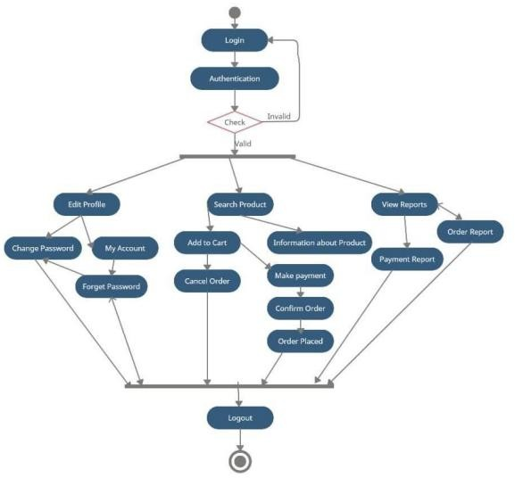

*Fig 4.5 – ACTIVITY DIAGRAM*

Activity diagrams are invaluable tools for visualizing complex processes and workflows, aiding in the identification of potential bottlenecks or inefficiencies. Their versatility allows for the representation of both high-level overviews and detailed step-by-step procedures, catering to diverse stakeholder needs.

**CHAPTER 5**

**RESULT AND DISCUSSION**

**5.1 PHPMYADMIN**

PhpMyAdmin is a web-based graphical user interface (GUI) tool used for managing MySQL databases. It provides users with a convenient way to perform various database administration tasks through a browser interface. With PhpMyAdmin, users can create, modify, and delete databases, tables, and fields, execute SQL queries, import and export data, manage user privileges, and more. Its intuitive interface and comprehensive features make it a popular choice for developers, database administrators, and website owners for efficiently managing MySQL databases multi-language support, allowing users to navigate and interact with the interface in their preferred language. Its extensive documentation and active community support further enhance its usability, making it accessible to users of all skill levels. PhpMyAdmin's continuous updates and improvements ensure compatibility with the latest MySQL versions and security standards.

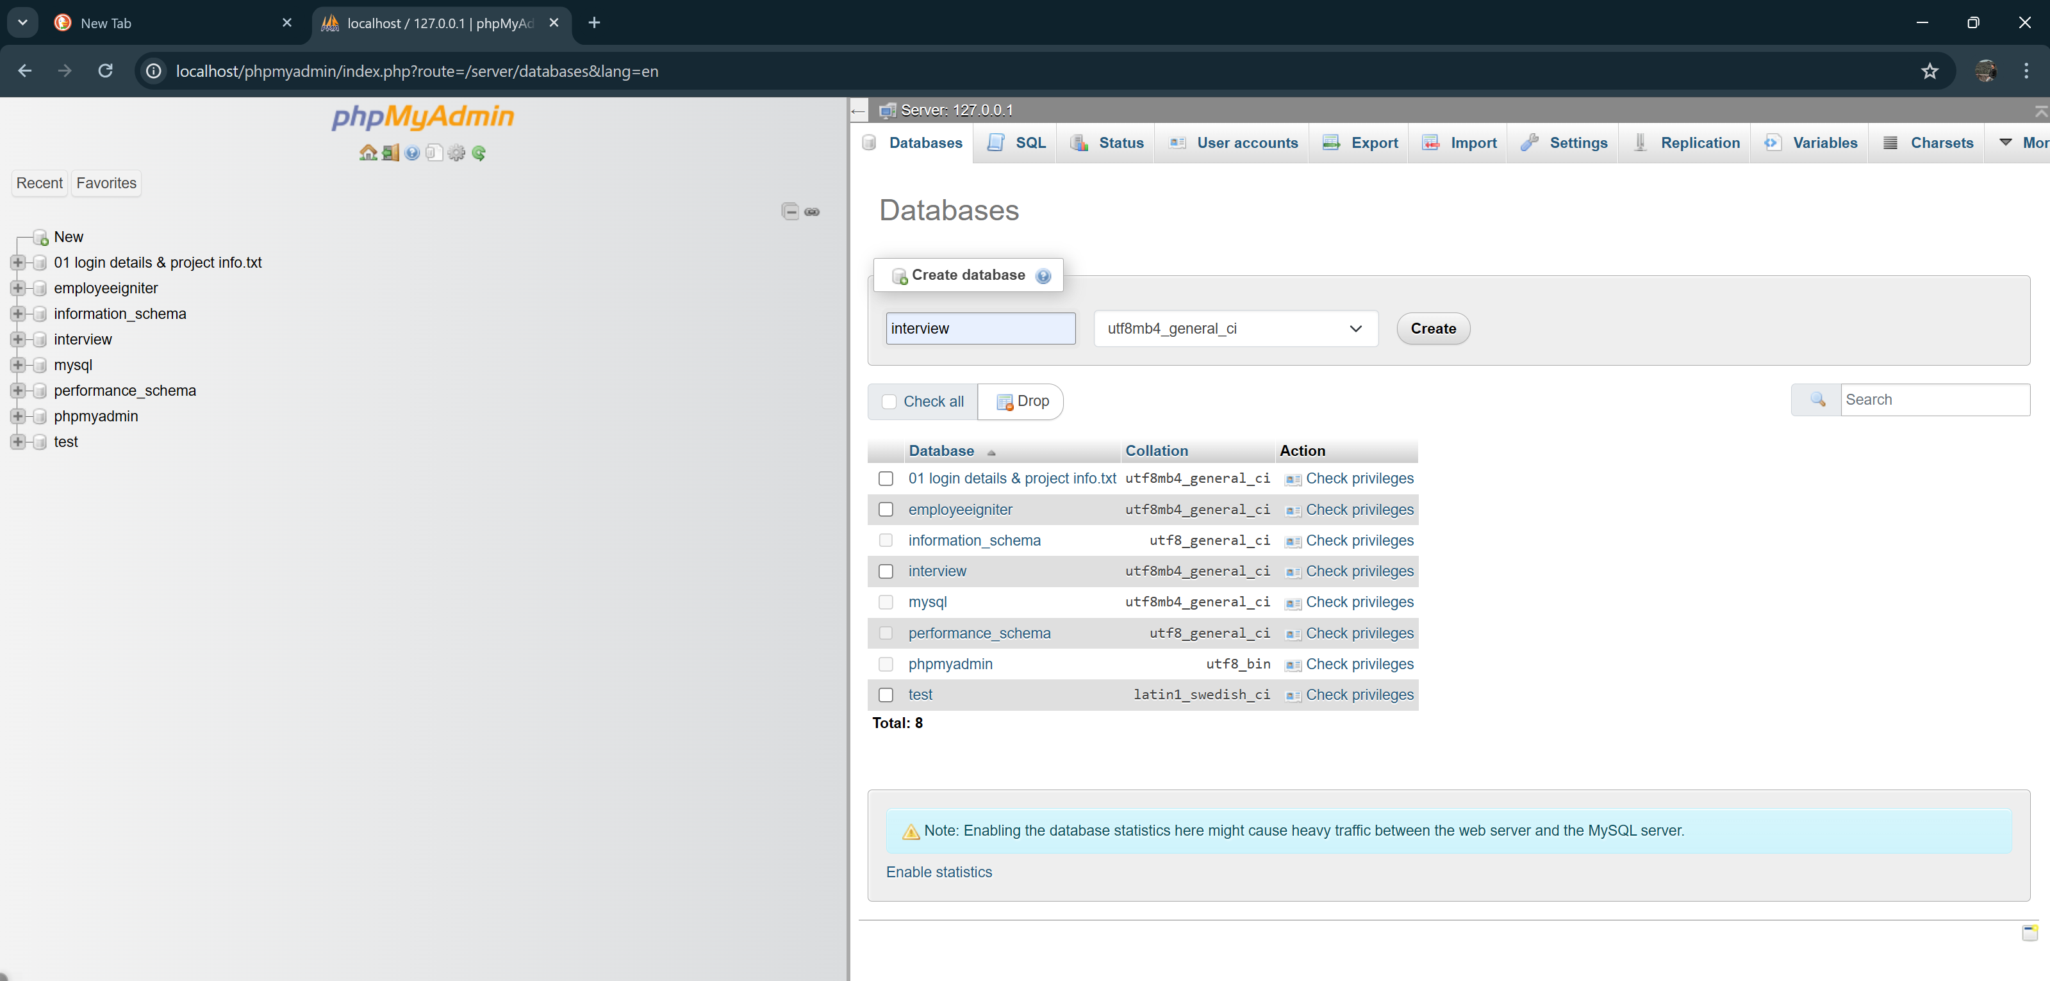

*Fig – 5.1 PHP MY ADMIN*

**5.2 HOME PAGE**

Homepage for agricultural supplies might feature sections dedicated to fertilizers, farming tools, seeds, plants, and additional details to assist users. In simple English, the homepage could be designed with clear navigation options, such as clickable images or buttons, leading users to specific product categories like fertilizers, tools, seeds, and plants. Each section could display featured products with brief descriptions and images, making it easy for customers to explore and find what they need. Additionally, the homepage might include promotional banners or announcements about special offers, seasonal products, or upcoming events relevant to agriculture. the homepage could incorporate search functionality, enabling users to quickly locate specific products or information. Interactive elements like tooltips or pop-ups could provide additional guidance or tips to users as they navigate the website. Integrating customer reviews or testimonials could also build trust and credibility, helping users make informed purchasing decisions.

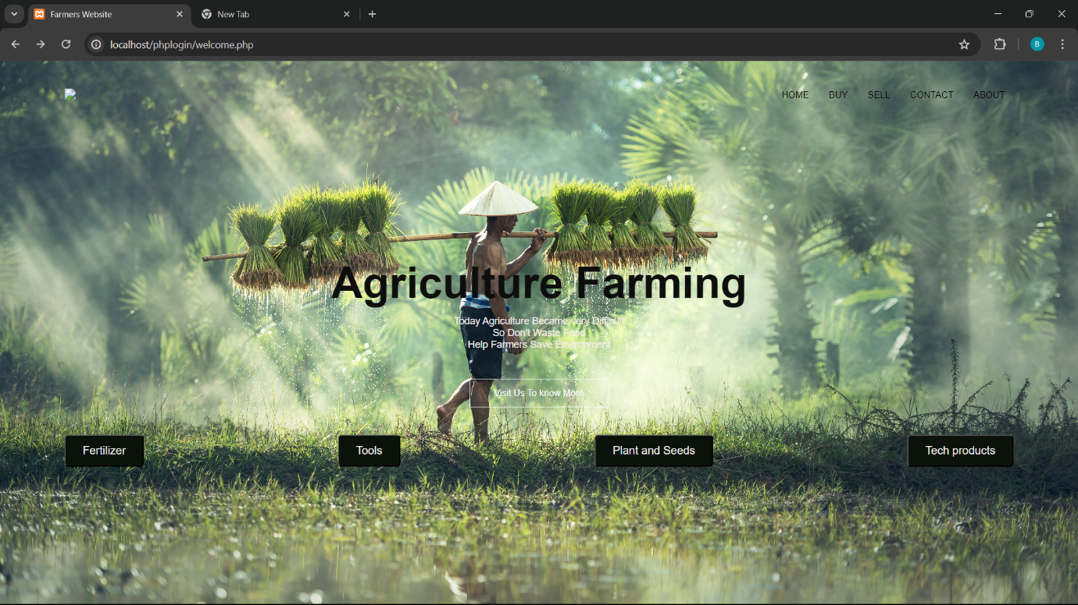

*Fig – 5.2 HOME PAGE*

**5.3 LOGIN PAGE**

On the homepage of the eCommerce website, there's a "Seller" button that directs users to the seller login page for authentication. This page requires sellers to input their login credentials, such as username and password, to access their accounts. Sellers use this authentication process to securely log in and manage their product listings, inventory, orders, and other selling-related activities on the platform. By providing a dedicated login page for sellers, the eCommerce website ensures the security and integrity of seller accounts while facilitating smooth interactions and transactions between sellers and the platform. the seller login page may incorporate additional security measures such as captcha verification or two-factor authentication to safeguard against unauthorized access. Once authenticated, sellers are granted access to a personalized dashboard where they can efficiently monitor and manage their selling activities. Regular updates and enhancements to the seller login interface ensure optimal usability and security standards, fostering a seamless and secure selling experience for all registered sellers on the platform.

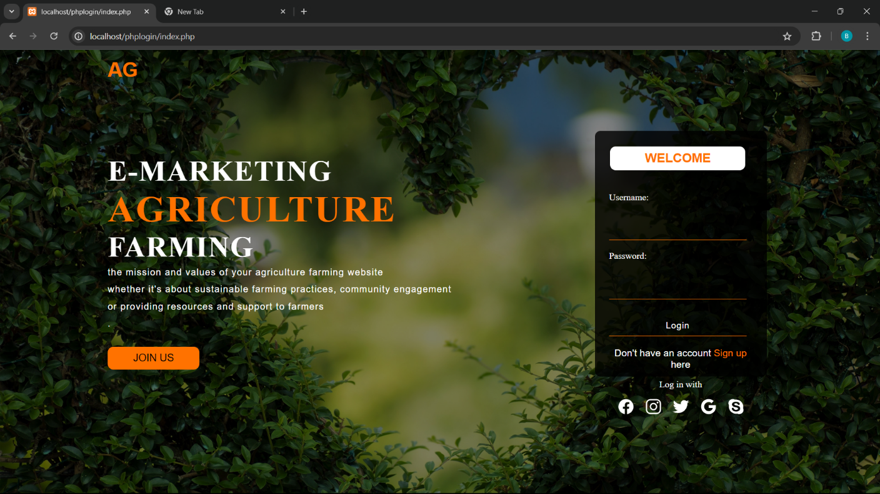

*Fig - 5.3 LOGIN PAGE*

**5.4 SELLER FORM**

After logging in to the seller page, sellers are presented with a form containing fields for entering product details. This form serves as a streamlined interface for sellers to input essential information about their products, including the product name, price, and category. Sellers can specify whether the product falls under categories such as fertilizers, plants, seeds, or tools. If the product is a fertilizer, an additional field prompts sellers to input the percentage composition of the active ingredient, typically expressed as a weight/volume (w/v) content. Sellers can easily fill out these fields with accurate information, ensuring that their products are properly categorized and described for potential buyers. This form provides sellers with a convenient and organized way to manage their product listings, enabling them to efficiently showcase their offerings on the eCommerce platform.

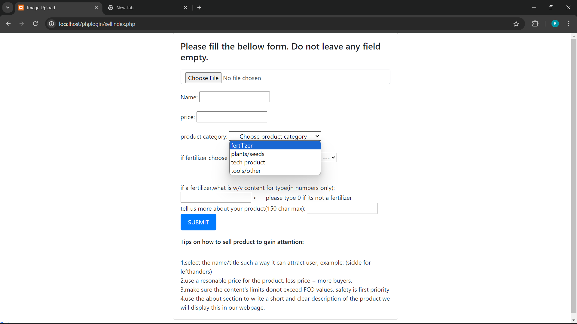

*Fig - 5.4 SELLER FORM*

sellers can upload images of their products directly within the form, enhancing the visual appeal and attractiveness of their listings to potential buyers.

**5.5 PRODUCTS PAGE**

After adding products to the website, they become available for customers to browse and purchase on another page, typically the product listing or shop page. Here, customers can view a variety of products with features like "Add to Cart," product pricing, and a search function to easily find specific items. The "Add to Cart" button allows customers to select products they wish to purchase and store them temporarily while continuing to shop. Product pricing is prominently displayed alongside each item, ensuring transparency and aiding customers in making informed purchasing decisions. The search function enables customers to quickly locate products by name, category, or other relevant criteria, enhancing the overall shopping experience. Together, these features create a user-friendly environment where customers can explore, select, and purchase products with ease.

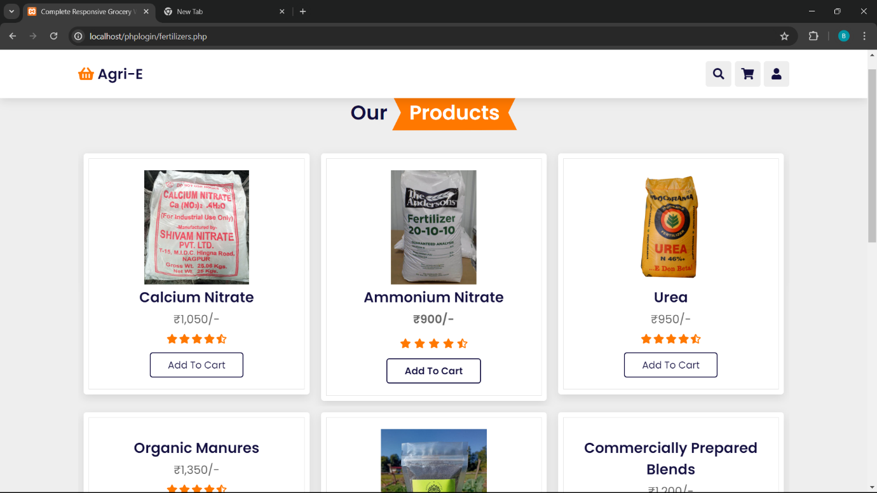

*Fig - 5.5 PRODUCTS PAGE*

The product listing page may include sorting and filtering options, allowing customers to refine their search results based on factors such as price range.

**5.6 SQL DATABASE**

When a seller enters data on a website, such as product information, pricing, and categories, this data is typically stored in a MySQL database. MySQL is a popular relational database management system used for storing and managing structured data. Each piece of information entered by the seller, like product names, descriptions, prices, and categories, is organized into tables within the database. These tables are designed to efficiently store and retrieve data, ensuring that seller-entered information is accurately captured and easily accessible. By leveraging MySQL databases, websites can securely manage vast amounts of seller data, facilitating smooth operations and enabling seamless interactions between sellers and customer MySQL databases provide robust features such as data indexing and querying capabilities, optimizing the performance of data retrieval operations even as the database grows in size. With MySQL's reliability and scalability, websites can confidently handle increasing volumes of seller data while maintaining high levels of system responsiveness and integrity.

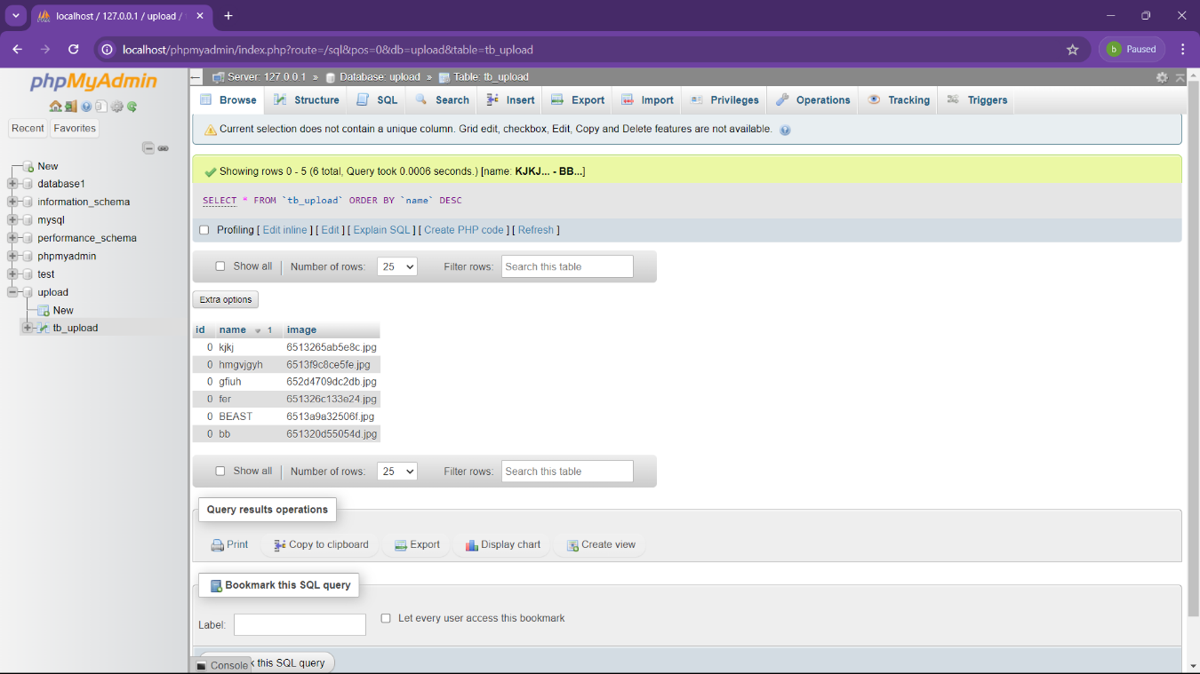

*Fig – 5.6 SQL DATABASE*

**5.7 CHATBOT**

In an agriculture eCommerce website, a chatbot can serve as a valuable assistant to farmers, helping them navigate the platform and find the products they need efficiently. Firstly, the chatbot can greet farmers upon arrival, guidingthem through the website's offerings and answering any initial questions they may have. It can assist farmers in searching for specific products, providing information about fertilizers, seeds, tools, and other agricultural essentials. By understanding farmers' requirements and preferences, the chatbot can offer personalized product recommendations, highlighting items suited to their crops, soil type, and farming practices. Moreover, the chatbot can aid farmers in placing orders, tracking deliveries, and accessing support services, simplifying the purchasing process and saving valuable time. the chatbot can provide valuable insights and tips on farming techniques, pest management, and crop cultivation practices, enhancing farmers' knowledge and productivity. Through continuous learning and improvement, the chatbot adapts to farmers' needs, ensuring a seamless and intuitive user experience.



*Fig 5.7 CHATBOT*

**5.8 CHAT ASSIST**

The chatbot plays a crucial role in empowering farmers with knowledge and resources to improve their farming practices. Through interactive conversations, the chatbot can provide valuable insights, tips, and advice on crop management, pest control, irrigation techniques, and soil health. It can offer educational content, such as articles, tutorials, and videos, to help farmers stay informed about the latest agricultural innovations and best practices. Additionally, the chatbot can connect farmers with agricultural experts, extension services, and community forums, fostering collaboration and knowledge sharing within the farming community. By serving as a reliable and accessible resource, the chatbot enhances farmers' capabilities, enabling them to make informed decisions and achieve greater success in their agricultural endeavors. The chatbot's ability to provide real-time assistance ensures that farmers have immediate access to support whenever they encounter challenges or have questions while working on their farms. By leveraging machine learning algorithms.

*Fig - 5.1 CHAT ASSIST*

**5.9 PAYMENT PAGE**

The payment page serves as a crucial component in the eCommerce website, facilitating secure transactions between customers and the platform. Users are presented with various payment options, including credit/debit cards, digital wallets, and ban1k transfers, ensuring convenience and flexibility. The page is designed with robust security measures, including encryption and authentication protocols, to safeguard sensitive financial information and prevent unauthorized access. Customers can securely input their payment details, review their order summary, and proceed to complete the transaction seamlessly. Real-time validation and verification mechanisms are employed to ensure accuracy and integrity throughout the payment process, providing users with confidence and peace of mind. Overall, the payment page streamlines the checkout experience, enabling smooth and hassle-free transactions while maintaining the highest standards of security and reliability

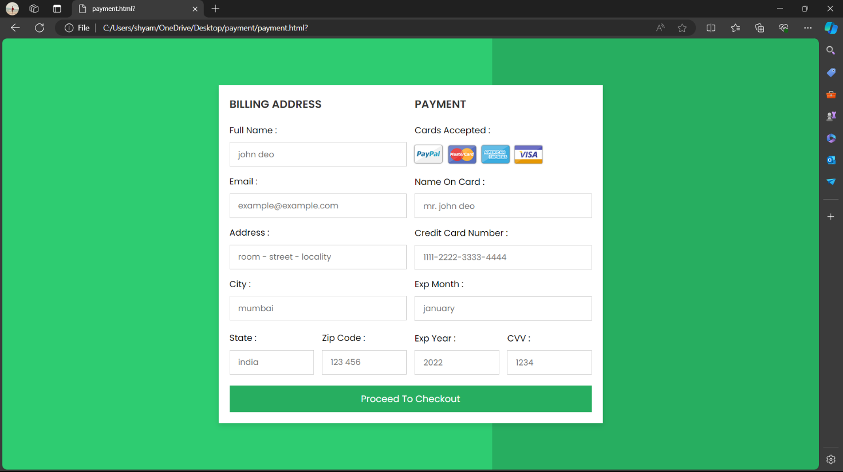

*Fig – 5.9 Payment*

**5.10 RESULT**

An interactive Chatbot connected to an Agricultural website which helps in providing efficient communication between farmers and agricultural experts. Most of the farmers do not have proper knowledge of sites and applications. they often don’t have an idea of online product posting, web applications etc. but our proposed system is much easier to access by them without the involvement of third party and middle men. Through this portal farmers can get much profit by selling their products online. If farmer has any doubts they can clarify it by receiving personalized advice from agricultural experts on issues such as soil quality, pests and disease control through chatbot. It also enhances customer service by helping farmers build stronger relationships with their clients and increase customer satisfaction. The location of nearest soil testing labs can also be viewed by farmers and crop recommendation for the particular type of soil will also be suggested. The information about various schemes provided by government can also be viewed. The details about Direct Purchase Centers and Open Weather Forecast with real time weather updates which helps in making decisions about planting, harvesting and other activities are also available. Overall chatbot have the potential to transform the agriculture industry by providing farmers with quick and efficient access to agricultural advice and information.

The chatbot's integration with the agricultural website ensures seamless communication between farmers and experts, bridging the gap in knowledge and technology literacy. By simplifying the process of online product posting and facilitating direct interactions, farmers can maximize their profits without relying on intermediaries. Access to personalized advice from experts empowers farmers to make informed decisions, leading to improved crop yield and sustainability. Additionally, by providing information on government schemes, soil testing labs, and weather forecasts, the chatbot equips farmers with essential resources to enhance their farming practices and mitigate risks. Ultimately, the chatbot serves as a catalyst for positive change in the agriculture industry, promoting efficiency, profitability, and resilience among farming communities.

**CHAPTER 6**

**CONCLUSION AND FUTURE WORK**

This analysis confirms that E-commerce will help the farmers in a way that they achieve some profits for their hard work. The Ecommerce System is needed to improve farming in rural society to make them aware of crops and their market prices. This type of system is also helpful for the government to get the proper information about the crops available in their respective areas. The study we made has predicted that the development and transformation of E-commerce is a creative way of controlling and market access for smallholders. We will develop a system that is easy and simple to use by every rural farmer. The project we are doing will provide maximum earnings to the farmers who do not get profits due to the wholesalers who quote their price for the crops. All these unique technologies, advanced software solutions and network reforms will help the farmers grow more and more and we strive for a better future for farmers. Payment integration, order tracking and a more attractive UI will be developed in the future, based on the scope of project.

The implementation of E-commerce in rural areas not only empowers farmers to access market prices for their crops but also facilitates the collection of valuable data for government agencies to better understand agricultural trends and make informed policy decisions. By providing a platform that caters to the specific needs and capabilities of rural farmers, we aim to democratize access to markets and resources, leveling the playing field for smallholders. Through continuous improvement and innovation, we are committed to enhancing the user experience and functionality of our E-commerce system, ensuring that it remains relevant and effective in meeting the evolving needs of farmers and stakeholders. As we integrate features like payment integration and order tracking, we aim to streamline the buying and selling process, further increasing efficiency and profitability for farmers. Ultimately, our vision is to foster a sustainable and prosperous future for rural communities, where farmers are empowered to thrive and contribute to agricultural development.

**REFERENCES**

1. Peter Namisko and Moses Aballo “Current status of agriculture and Global Trends” in International Journal of Science and Research Volume 2 Issue 7,2013.
2. “E-Commerce in agri-food sector: a systematic literature review” by Yiwu Zeng, Fu Jia, Lia Wan and HongdongGuo in the International Food and Agriculture Management Review on 26 February 2017.
3. “A Survey Conducted on E-Agriculture with Indian Farmers” by SumithaThankachan, Dr.S.Kirubakaran in International Journal of Computer Science and Mobile Computing on 2 February 2014.
4. “A study of Segments Contribution: E-commerce growth in India” by Mahipal.D in Academy of mar- keting Studies Journal in 2018.
5. “Emerging Trends of E-Commerce in India: An Empirical Study” by Shetter .M in International Journal of Business and Management Invention in 2016.
6. “Understanding E-Commerce: A study with reference to competitive economy” by Neha Wadhawan and RK Arya in Journal of Critical Reviews on 25 June 2020
7. “The Need of Agribusiness E-commerce to Support Staple Food Self- Sufficiency” by UjangMaman and YuniSugiarati in the International Journal of Applied Agricultural Research in 2016.
8. “Agriculture in India: A SWOT analysis” by N.Praveen Kumar in Indian Journal of Applied Research in 2013.
9. Peter Namisiko and Moses Aballo “Current Status of e-Agriculture and Global Trends: A Survey Con-
10. ducted in TransNzoia County, Kenya” in International Journal of Science and Research Volume 2 Issue 7, 2013.
11. Wang Yujia, ”Evaluation and Analysis on Agri-enterprises Websites Functions”, Chengdu: University of Electronic, June 2006.
12. Nidhi Dwivedy “Challenges faced by the Agriculture Sector in Developing Countries with special ref- erence to India” in International Journal of Rural Studies vol. 18 no. 2, 2011.

**APPENDIX**

**SOURCE CODE**

***Homepage:***

<!DOCTYPE html>

<html lang="en">

<head>

<meta name="viewport" content="width=device-width, initial-scale=1.0">

<title>Farmers Website</title>

<link rel="stylesheet" href="welcome.css">

<link rel="preconnect" href="https://fonts.googleapis.com">

<link href="https://fonts.googleapis.com/css2?

family=Poppins:wght@700&display=swap" rel="stylesheet">

<link rel="stylesheet" href="https://cdn.jsdelivr.net/npm/

@fortawesome/fontawesome-free@6.1.2/css/fontawesome.min.css">

<style>

/* Add this CSS for medium-sized buttons */

.products button {

padding: 12px 24px; /* Adjust padding for medium size */

font-size: 16px; /* Adjust font size for medium size */

}

</style>

</head>

<body>

<section class="header">

<nav>

<a href="Bobby.html"><img src="images/logo.png"></a>

<div class="nav-links" id="navLinks">

<i class="fa fa-times"></i>

<ul>

<li><a href="">HOME</a></li>

<li><a href="http://localhost/phplogin/datanew.php">BUY</a></li>

<li><a href="http://localhost/phplogin/index.php">SELL</a></li>

<li><a href="http://localhost/phplogin/contact.php">CONTACT</a></li>

<li><a href="http://localhost/phplogin/contact.php">ABOUT</a></li>

</ul>

</div>

<i class="fa fa-bars"></i>

</nav>

</nav>

<div class="text-box">

<h1>Agriculture Farming</h1>

<p>Today Agriculture Became very Difficult<br>So Don't Waste Food

<br>Help Farmers Save Environment

</p>

<a href="" class="hero-btn">Visit Us To know More</a>

</div>

<br></br>

<br></br>

<section class="products">

<nav>

<a href="http://localhost/phplogin/fertilizers.php">

<button onclick="doSomething()"

style="background-color:#0a120a;color:#f5f1f1;border-radius:5px">

Fertilizer</button><</a>

<a href="D:\New folder\PROJECT\proj final\tools.html">

<button onclick="doSomething()"

style="background-color:#0a120a;color:#f5f1f1;border-radius:5px">

Tools</button><br>

</a>

<a href="D:\New folder\PROJECT\proj final\seeds.html">

<button onclick="doSomething()"

style="background-color:#0a120a;color:#f5f1f1;border-radius:5px">

Plant and Seeds</button><br>

</a>

<a href="file:///D:/New%20folder/PROJECT/proj%20final/hello.html">

<button onclick="doSomething()"

style="background-color:#0a120a;color:#f5f1f1;border-radius:5px"

>Tech products</button><br>

</a>

</nav>

<section>

</body>

</section>

</section>

</section>

</body>

</html>

***Login page:***

<?php

require "connection.php";

if(isset($_POST["submit"])){

$name = $_POST["name"];

if($_FILES["image"]["error"] == 4){

echo

"<script> alert('Image Does Not Exist'); </script>"

;

}

else{

$fileName = $_FILES["image"]["name"];

$fileSize = $_FILES["image"]["size"];

$tmpName = $_FILES["image"]["tmp_name"];

$validImageExtension = ['jpg', 'jpeg', 'png'];

$imageExtension = explode('.', $fileName);

$imageExtension = strtolower(end($imageExtension));

if ( !in_array($imageExtension, $validImageExtension) ){

echo

"

<script>

alert('Invalid Image Extension');

</script>

";

}

else if($fileSize > 1000000){

echo

"

<script>

alert('Image Size Is Too Large');

</script>

";

}

else{

$newImageName = uniqid();

$newImageName .= '.' . $imageExtension;

move_uploaded_file($tmpName, 'img/' . $newImageName);

$query = "INSERT INTO tb_upload VALUES('', '$name', '$newImageName')";

mysqli_query($conn, $query);

echo

"

<script>

alert('Successfully Added');

document.location.href = 'selldata.php';

</script>

";

}

}

}

?>

<!DOCTYPE html>

<html>

<head>

<title>Image Upload</title>

<link rel="stylesheet" href="https://cdn.jsdelivr.net/npm/bootstrap@4.6.1/dist/css/bootstrap.min.css">

<link rel="stylesheet" type="text/css" href="sellcss.css" />

<script src="agri.js"></script>

</head>

<body>

<div id="content">

<form method="POST" action="" enctype="multipart/form-data">

<h4> Please fill the bellow form. Do not leave any field empty.</h4>

<div class="form-group">

<input class="form-control" type="file" name="uploadfile" value="" />

</div>

<div>

Name: <input type="text" name="name"><br><br>

price: <input type="text" name="price"><br><br>

<!--type: <input type="text" name="type"><br>-->

<label for="type">product category:</label>

<select name="type" id="type" >

<option value="" selected="selected" hidden="hidden">--- Choose product category---</option>

<option value="f" >fertilizer</option>

<option value="p">plants/seeds</option>

<option value="tp">tech product</option>

<option value="t">tools/other</option>

</select><br><br>

<label for="color">if fertilizer choose type:</label>

<select name="color" id="color" >

<option value="" selected="selected" hidden="hidden">--- Choose a type of fertlizer ---</option>

<option value="nitrogen based" >nitrogen based</option>

<option value="urea based">urea based</option>

<option value="Ammonium based">Ammonium based</option>

<option value="">not a fertilizer</option>

</select><br><br><br>

if a fertilizer,what is w/v content for type(in numbers only): <input type="text" name="content"> <--- please type 0 if its not a fertilizer<br>

tell us more about your product(150 char max): <input type="text" name="about"><br>

</div>

<div class="form-group">

<button class="btn btn-primary" type="submit" name="upload" >SUBMIT</button><br>

</div>

<div>

<h6> Tips on how to sell product to gain attention: </h6><br>

1.select the name/title such a way it can attract user, example: (sickle for lefthanders)<br>

2.use a resonable price for the product. less price = more buyers.<br>

3.make sure the content's limits donot exceed FCO values. safety is first priority<br>

4.use the about section to write a short and clear description of the product we will display this in our webpage.<br>

</div>

</form>

</div>

</select>

</div>

<a href="selldata.php">Data</a>

</body>

</html>

***Chatbot:***

<!DOCTYPE html>

<html lang="en">

<head>

<meta charset="UTF-8">

<meta http-equiv="X-UA-Compatible" content="IE=edge">

<meta name="viewport" content="width=device-width, initial-scale=1.0">

<title>Chat Bot</title>

<link rel="stylesheet" href="ststic/css/chat.css">

<link rel="stylesheet" href="ststic/css/home.css">

<link rel="stylesheet" href="https://cdnjs.cloudflare.com/ajax/libs/font-awesome/4.7.0/css/font-awesome.min.css">

<style>

body {

margin: 0;

padding: 0;

font-family: Helvetica, sans-serif, Arial;

min-height: 100vh;

width: 100%;

background-image: url("bggin.jpg");

background-position: center;

background-size: cover;

position: relative;

}

</style>

</head>

<body>

<!-- CHAT BAR BLOCK -->

<div class="chat-bar-collapsible">

<button id="chat-button" type="button" class="collapsible">Chat with us!

<i id="chat-icon" style="color: #fff;" class="fa fa-fw fa-comments-o"></i>

</button>

<div class="content">

<div class="full-chat-block">

<!-- Message Container -->

<div class="outer-container">

<div class="chat-container">

<!-- Messages -->

<div id="chatbox">

<h5 id="chat-timestamp"></h5>

<p id="botStarterMessage" class="botText"><span>Loading...</span></p>

</div>

<!-- User input box -->

<div class="chat-bar-input-block">

<div id="userInput">

<input id="textInput" class="input-box" type="text" name="msg"

placeholder="Tap 'Enter' to send a message">

<p></p>

</div>

<div class="chat-bar-icons">

<i id="chat-icon" style="color: crimson;" class="fa fa-fw fa-heart"

onclick="heartButton()"></i>

<i id="chat-icon" style="color: #333;" class="fa fa-fw fa-send"

onclick="sendButton()"></i>

</div>

</div>

<div id="chat-bar-bottom">

<p></p>

</div>

</div>

</div>

</div>

</div>

</div>

<script src="https://ajax.googleapis.com/ajax/libs/jquery/3.4.1/jquery.min.js"></script>

<script src="responses.js"></script>

<script src="chat.js"></script>

</body>

</html>